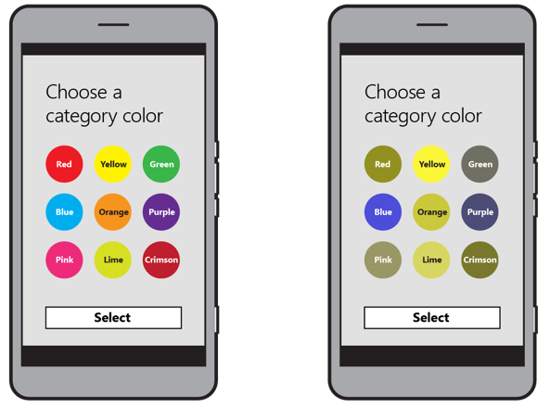

Not everyone has perfect vision, as a result it is key to add colour blind options. There are more than one variation of colour blindness so multiple ones will be added. An example of the change of colours which would be needed for one type of colour blind is shown above.

Type of colour blindness.

Deuteranopia : Deuteranomaly : Protanopia : Protanomaly

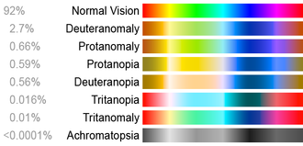

**Talk back**

Talk back is a default feature which is incorporated into android. This allows those who are nearly blind to still use their phones. Various ideas have been created within the team on whether or not to incorporate it. However, due to it being a default feature in android, the implementation should be relatively straight forward.

**Audio guide**

An audio guide is something which is used for directions. This can be enabled once a navigation section has started. Audio guides are very helpful when navigating due to the fact the user won’t have to look at their phone when navigating, but rather listen.